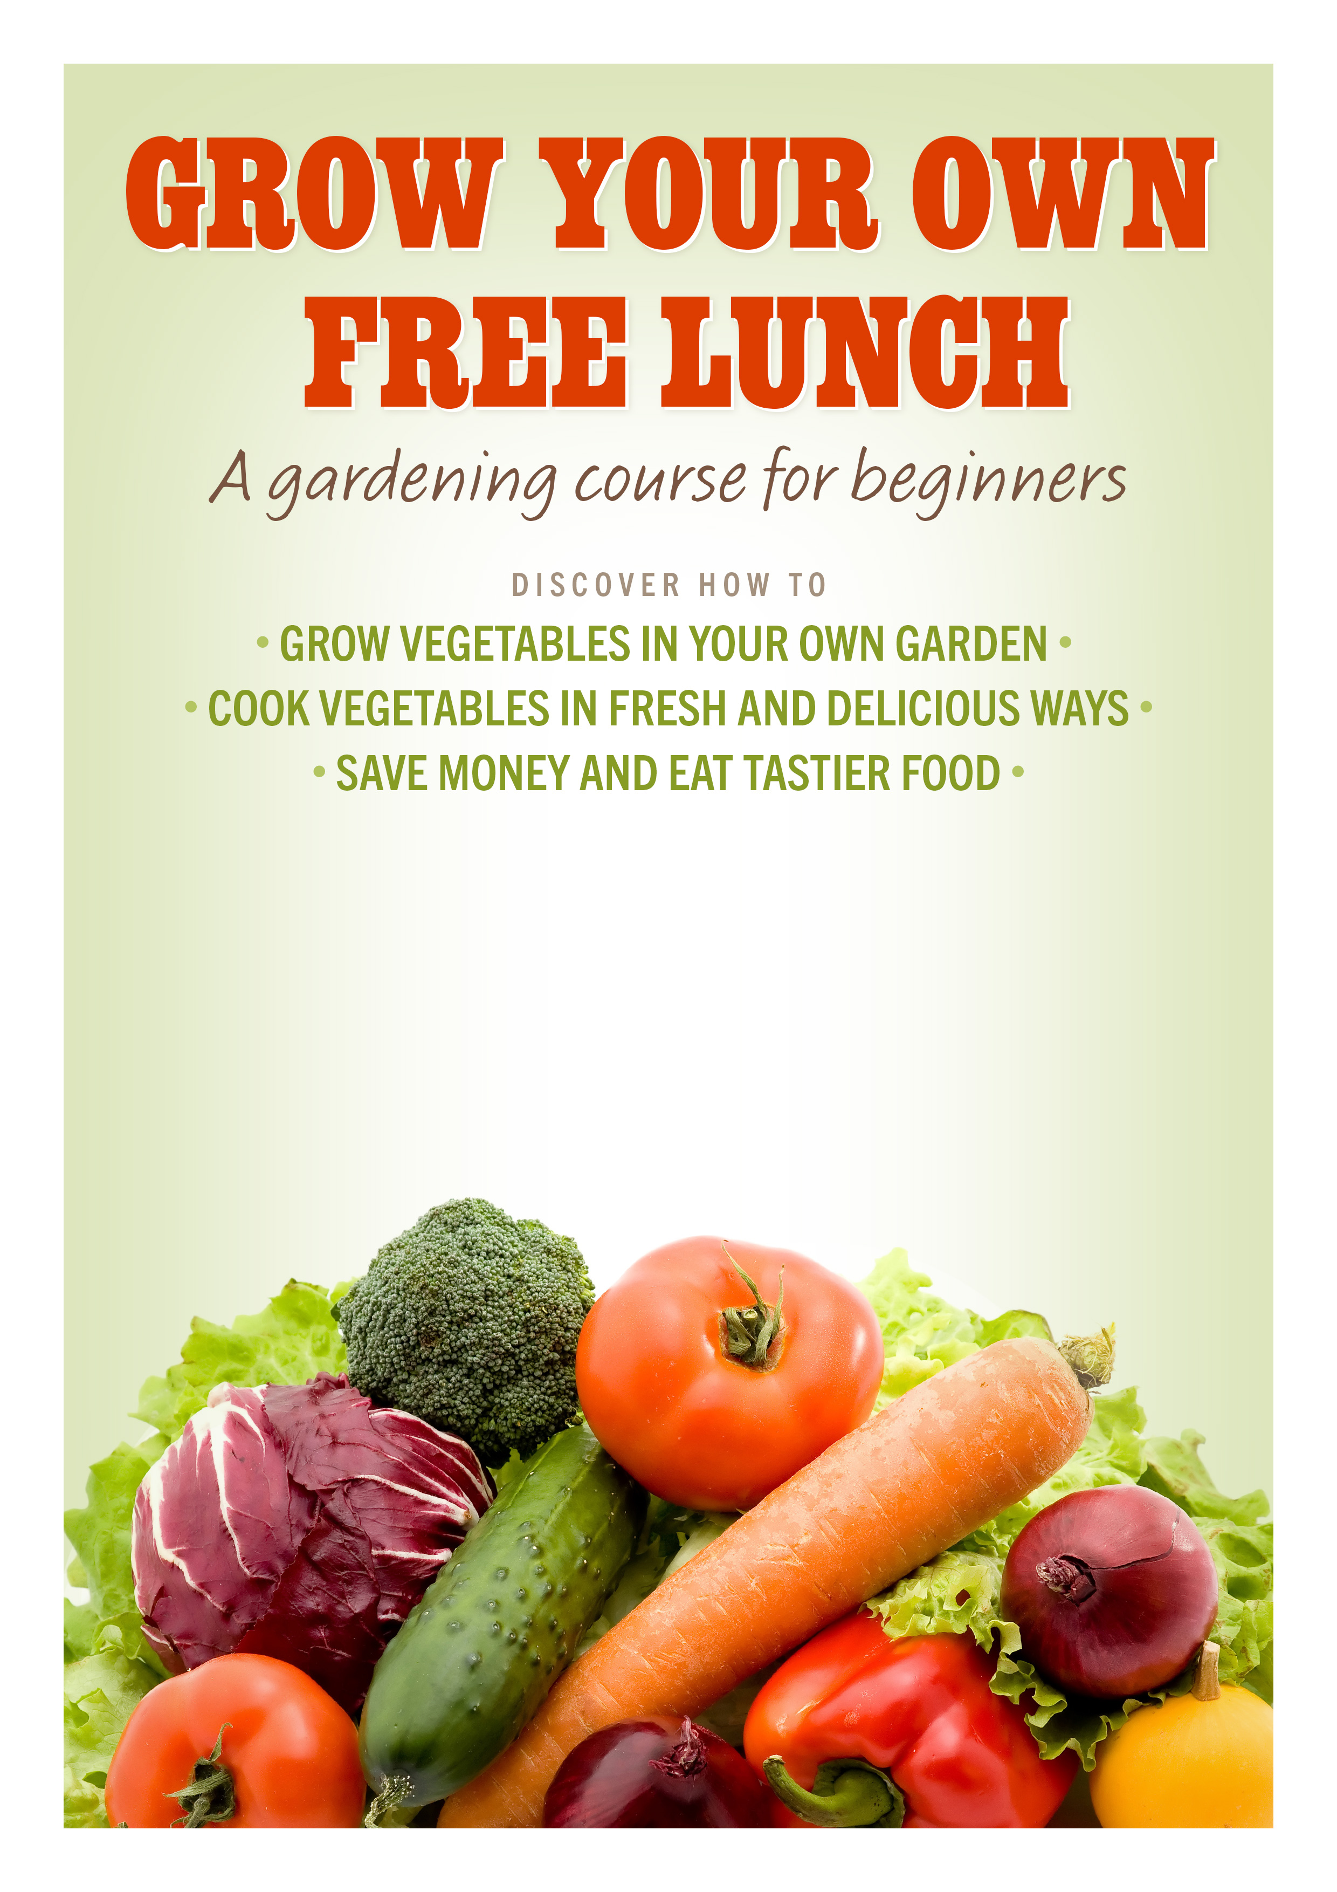
Four sessions on Thursdays
May 2, 9, 16, 23, 30. June 6
Avebury House 9.30 am – 1.45 pm

9 Eveleyn Couzins Ave, Richmond,
This is a FREE course. Book now.
Phone Delta Community House on 389 0212 or Mary on 022 699 41 43

